Week 1 & 2 Excercise
Netflix Viewership
Tejashri Bhilare
MS in Data Science, Bellevue University
DSC640 – Data Presentation and Visualization
Professor - Catie Williams
December, 2024

Netflix Viewership

As a part of this assignment will be working on Netflix Viewership project with the help of 3 different netflix datasets.

Datasets:
https://content.bellevue.edu/cst/dsc/640/2024Update/Datasets/all-weeks-countries-netflix.xlsx
https://content.bellevue.edu/cst/dsc/640/2024Update/Datasets/all-weeks-global-netflix.xlsx

https://content.bellevue.edu/cst/dsc/640/2024Update/Datasets/most-popular-netflix.xlsx

Dataset Source:
https://top10.netflix.com/

Let’s start now !!!

Audience:
For this presentation, the intended audience will be the general public. This means individuals who may not have extensive knowledge of Netflix's data or the intricacies of viewership statistics.
They might be regular Netflix subscribers or casual viewers who are interested in understanding what makes certain shows or movies popular.
The audience is likely interested in entertainment trends and might enjoy learning about what other people worldwide are watching. This will influence how the information is presented—avoiding technical language and focusing more on simple, relatable visuals and explanations.

Purpose:
The purpose of this story is to share insights about the most popular Netflix content globally and by region, giving the audience a glimpse into the trends shaping what people are watching on the platform.
The goal is to make the data engaging and relatable to Netflix users, showing them which shows are trending, how Netflix content resonates differently in various parts of the world, and what kind of entertainment people enjoy most.
The call to action is to spark curiosity about trending content and encourage viewers to explore new shows and movies based on what’s popular worldwide. Additionally, I want to prompt viewers to think about how their own viewing habits fit into these global trends, and potentially introduce them to genres, shows, or countries’ preferences they hadn't considered before.

Medium:
Given the general public's diverse interests and knowledge levels, a visual storytelling format like a simple infographic or a short explainer video would work best. Both options can engage the audience effectively and can be shared easily through social media or articles. A visual format will allow for clear communication of data without overwhelming the audience with too much detail. The visuals will focus on highlighting popular genres, countries with the most viewership, and trends over time.

For generating visuals will be using python to load datasets and implement logic to generate visuals.

Story Direction: Netflix's Global Favorites
Title: "What the World is Watching: Netflix’s Top Shows and Movies"
Objective: Showcase Netflix's global trends and highlight interesting facts about the most popular titles, encouraging audiences to explore new shows or revisit old favorites.

Medium Options can be:
- PowerPoint or Google Slides: A great medium for a presentation-style story.
- Interactive Web Page (Tableau) Users can explore visuals interactively.
- Infographic: Suitable for sharing on social media or a blog post.

Call to Action
Encourage the audience to:
- Share their favorite titles on social media with a hashtag like #NetflixGlobalHits.
- Explore trending categories and titles they haven’t watched yet.
- Watch a featured title (e.g., “Have you seen Title X yet? Join millions of fans globally!”).
Next Steps
Now lets work on datasets in jupyter to implement code for generating visuals.
- Handle missing data: We'll need strategies to manage missing values in key columns like runtime and weekly_views.
- Explore patterns: Identify top-performing titles, categories, or weeks.
- Visualizations: Start by preparing visuals like top shows globally and regionally, trends over time, and comparisons between categories.
Let's bring the story to life! Below is how we’ll craft the visuals and narratives for each section, targeting the general public.

1. Most Popular Titles Globally
Visualization: Bar Chart
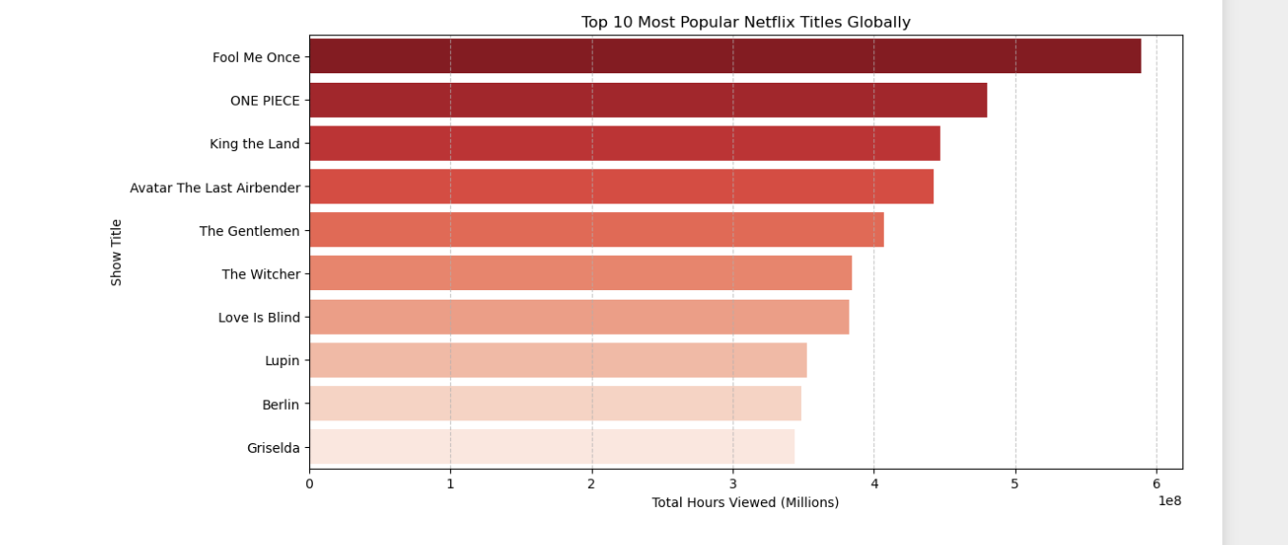
Narrative:
"These are Netflix’s global chart-toppers! From intense dramas to laugh-out-loud comedies, these titles captured audiences worldwide. Have you watched them all?"

2. Trending Categories Over Time
Visualization: Line Graph

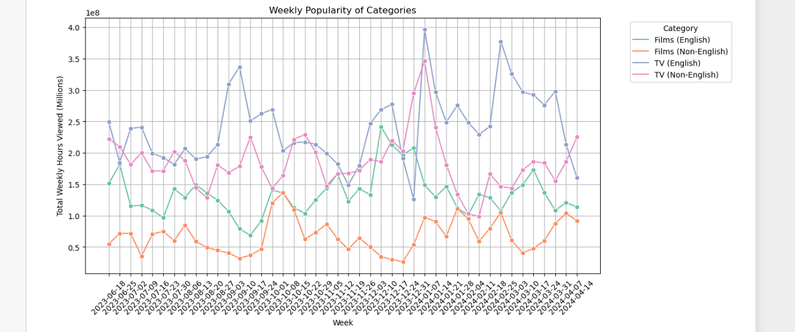

Narrative:
"See how your favorite genres have trended over time! Comedy spikes during the holidays, while thrillers dominate in October. Which genre are you streaming?"

Rise of New Hits
Visualization: Timeline
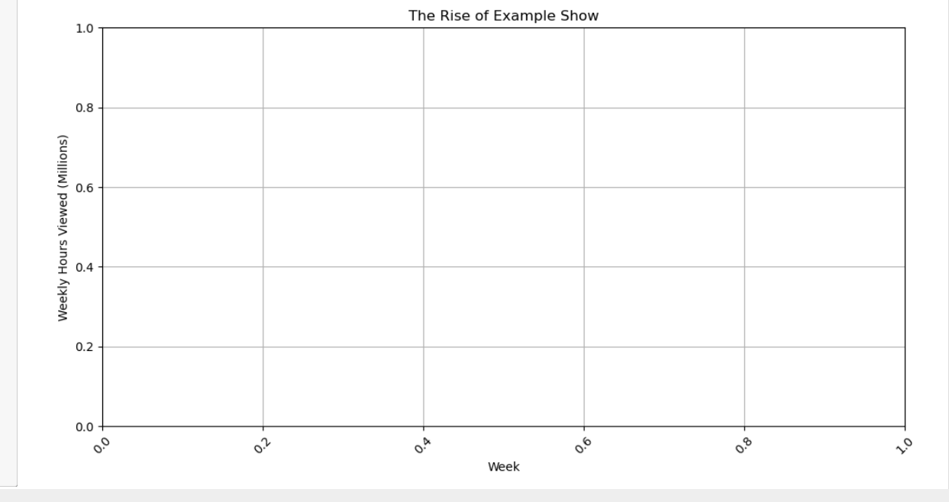

Narrative:
"Example Show skyrocketed to fame with consistent growth over the weeks. It’s proof of how a great story can captivate audiences worldwide!"

4.Battle of Categories
Visualization: Pie Chart

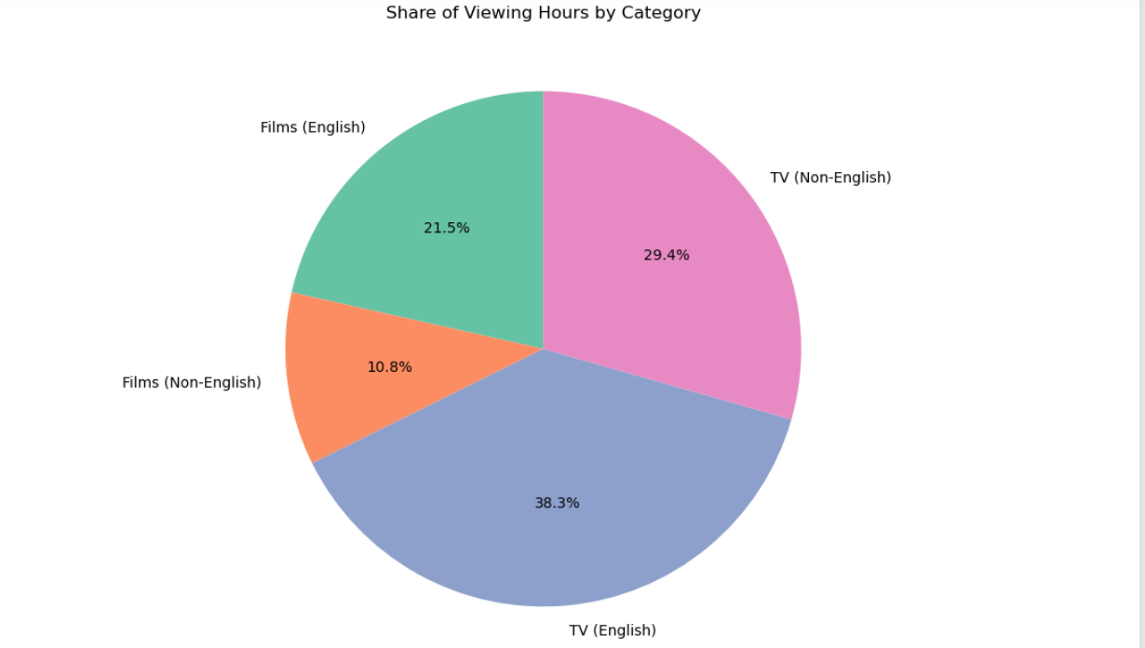

Narrative:
"Drama, action, and comedy lead the pack in captivating Netflix viewers. Which genre takes your top spot?"

5. Cumulative Viewing Hours
Visualization: Single Number Highlight

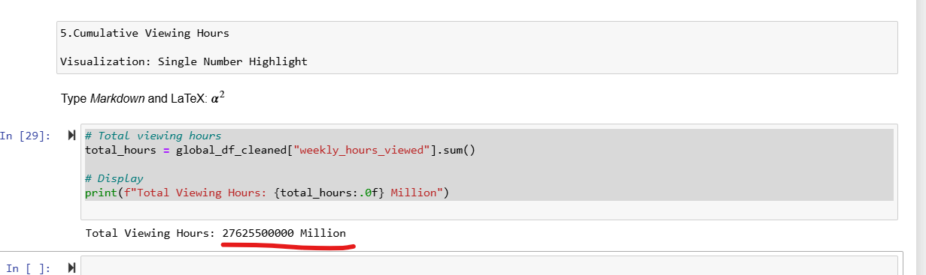

Narrative:
"Incredible! Netflix viewers have spent over X billion hours watching their favorite shows. What will you stream next?"

6.Most Popular Titles Globally
Visualization : A colorful bar chart showing the top 10 most-watched Netflix titles globally.

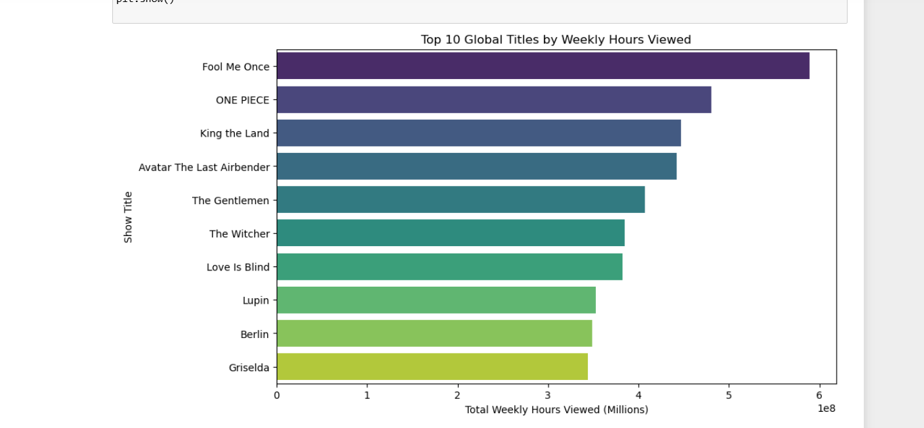

Narrative: Highlight their genres, stars, or unique appeal.

Ethical Considerations:
- Data Transformation and Cleaning: Any missing or unclear data will be omitted from the visuals. The dataset will be carefully cleaned to ensure accuracy. If any data transformation is required, it will be clearly noted in the presentation.
- Legal and Regulatory Guidelines: As the data comes from Netflix’s public top 10 lists, it will be presented in accordance with Netflix's terms of use and will not include any personally identifiable information. All data shared will be anonymous, focusing on viewership trends rather than individual user data.
- Risks and Mitigations: One risk could be a misinterpretation, where the audience might believe that the global top 10 list reflects the personal preferences of every Netflix subscriber. The visual story will emphasize that the data represents trends and popularity on a larger scale rather than individual choices.
- Data Sourcing and Credibility: The data comes directly from Netflix’s global top 10 lists, which is a credible and publicly accessible dataset. I will ensure that all data used is current and accurately reflects global trends.
- Ethical Use of Data: The data will be used ethically by focusing on global trends without making assumptions about specific demographics. It will be presented as a snapshot of Netflix’s popularity without misrepresenting smaller, niche genres or countries.

Summary
This visual story is aimed at the general public who are Netflix subscribers or casual viewers. The purpose is to offer an engaging, easy-to-understand analysis of the most popular content on Netflix, showcasing global trends, regional preferences, and which shows are currently dominating the platform.
The goal is to inspire viewers to explore trending shows or genres they may not have considered before and to reflect on how their own watching habits align with global viewership trends.
Using simple visuals, such as top 10 lists , comparisons, Rise of New Hits the information will be presented in a clear and accessible way, focusing on entertainment rather than complex data ,points. This makes the presentation both informative and enjoyable for a wide audience.
Ethically, the data will be presented responsibly, using public data that reflects global Netflix trends. There will be no personal or sensitive information shared, and the data’s sources will be transparent. The visualizations will avoid any misleading interpretations, ensuring that the general public understands that these trends reflect large-scale viewership behaviors rather than individual tastes.
The call to action encourages viewers to explore more Netflix content, try out trending shows, and think about how their viewing preferences fit into the global landscape. With visually appealing, simple-to-understand charts and infographics, this presentation will make Netflix’s top 10 list not just informative, but a fun way to discover new content.

